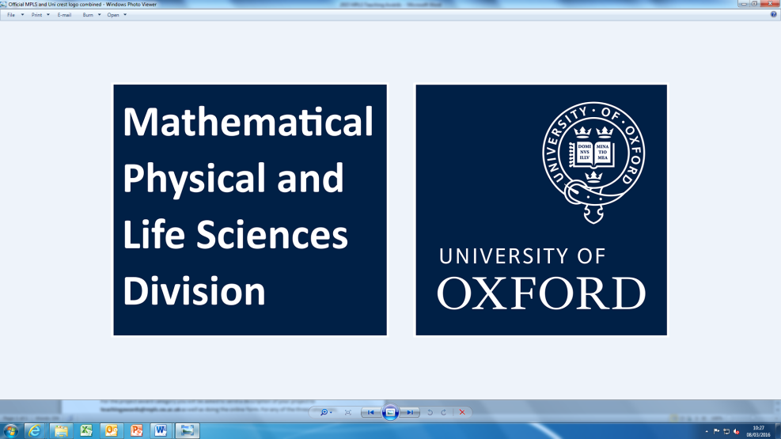

**Mathematical, Physical and Life Sciences Division – Teaching Awards 2025**

The MPLS Divisional Teaching Award Scheme celebrates success, and recognises innovation and/or leadership in teaching. Awards are available to all those who teach, including graduate students, postdoctoral researchers and learning support staff. The Teaching Award Scheme is administered by the MPLS Divisional Office and awards are made, on merit, across the departments by a cross-departmental panel chaired by the Associate Head of Division (Taught Degrees).

Nominations open on 1st March and may be made by academics, staff and students. You can nominate yourself or another person. Nominations can be for teaching or teaching-related activities conducted over the 2024-25 academic year, although nominations can also be made for teaching conduced in Trinity Term of 2024 if this has not been nominated previously.

Once all nominations have been gathered, each department will shortlist nominations from their departments and then finally our panel will decide the winners.

**The deadline for submitting nominations is 30th April 2025.**

There are between 5-10 individual awards given for innovation and/or leadership in teaching. These divisional awards carry a financial award of £1,000 per awardee (subject to usual tax).

**How to nominate**

To nominate yourself or another person for either of the categories, you will need to fill in a nomination form at:

<https://app.onlinesurveys.jisc.ac.uk/s/oxford/mpls-teaching-awards-2025>

Any supporting evidence can be sent to [teachingawards@mpls.ox.ac.uk](mailto:teachingawards@mpls.ox.ac.uk)

In the past, some nominations have not been very detailed which puts them at a disadvantage so please use as much detail as possible.

Further information on the awards, including previous winners and a range of possible reasons for nomination can be found at <https://www.mpls.ox.ac.uk/study/additionalinformation/teaching-awards>