**Pub**

**The Black Boy** - 91 Old High St

**Restaurant**

**Jacobs & Field** - 15 Old High St, Oxford

Dinner is at 7pm.

**Directions**

It takes about 5 minutes on foot to get to the restaurant from the pub. The quickest way to get there is by bus. The bus stop is at **High Street (Stop T2)**, which is located in the city centre, and one should take either **Bus 8, 9, BROOKESbus U1 or Sapphire 280** and get off at **Headington Shops (Stop HS6)**. The journey takes 13 minutes, and there are buses every 6 minutes.

\**Some of us are going to meet at 5.30pm to go to the pub together. We will meet in the Mathematical Institute, so feel free to come with us!*

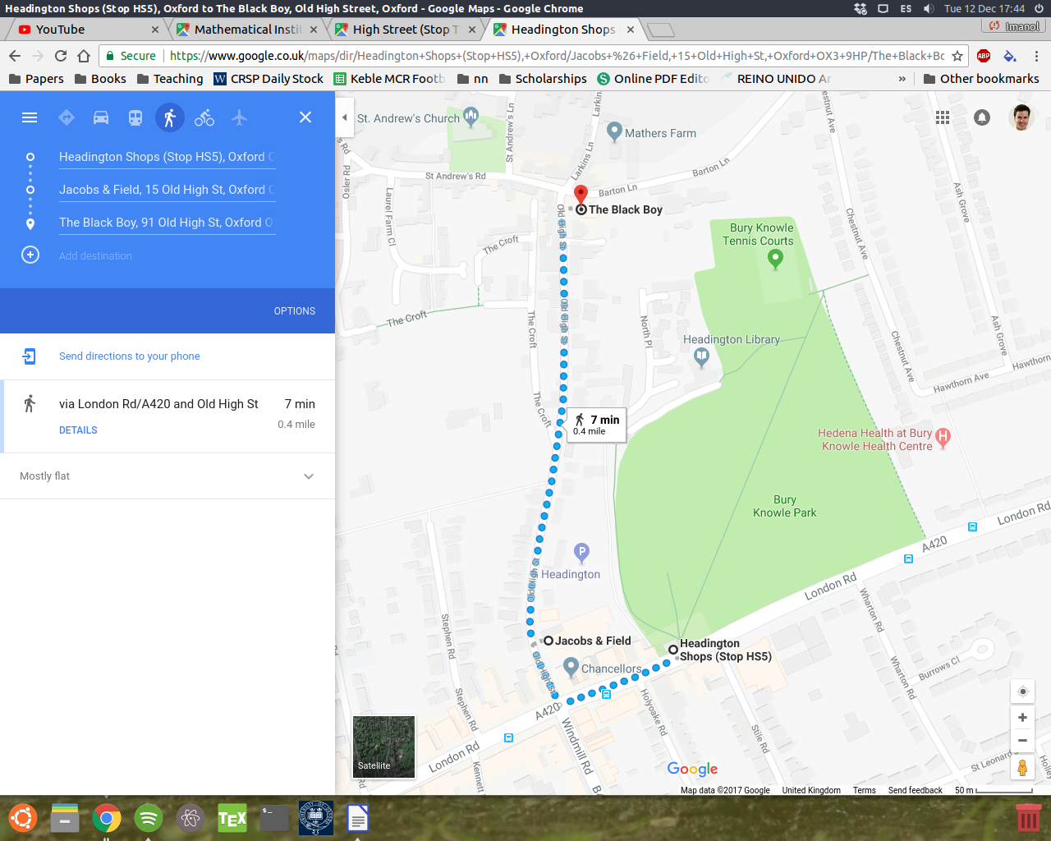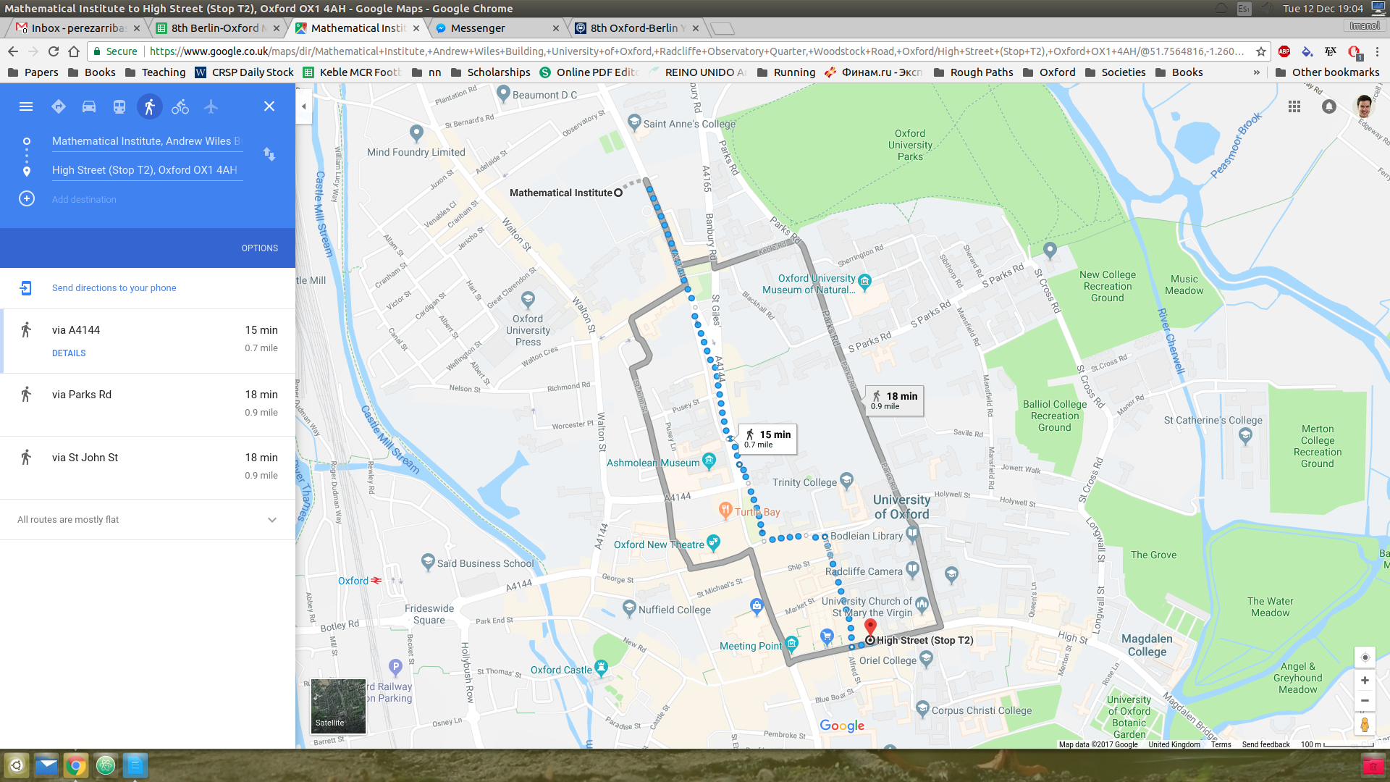

Restaurant

Restaurant

Pub